Overton Public School Mark A. Aten, Superintendent
P.O. Box 310, 401 7th St. Brian Fleischman, Principal /
Overton, NE 68863-0310 Activities Director
Calli McCoy, Counselor

Phone (308) 987-2424 Fax (308) 987-2349 www.overtoneagles.org

March 24, 2020

Dear Parent/Guardians,

This letter is to inform you that Overton Public School has plans for extended learning opportunities during our extended school closure. This letter is intended for communication and awareness purposes. More information will follow in the form of emails and postings on the school website.

We have reviewed our procedures and are confident we will be prepared to respond to an extended school closure. We have created an Extended Learning Plan which will include online learning along with learning packets to be picked up or sent home. The teachers are currently creating plans to transition from our enrichment learning environment to our extended learning environment. Within our extended learning environment, new material will be presented in a variety of ways including recorded lecture sessions, Zoom meetings, Schoology assignments, learning packets sent home, and many others. Our goal is to continue to move the education of our students forward in a manner conducive to the current environment we are living in. It is impossible to replicate the school day in an extended learning environment but our goal is to provide learning opportunities that mimic a regular school day in a modified format. The Extended Learning Plan will be shared with parents and students in the coming days.

I want to encourage parents to recognize flu-type looking symptoms such as fever, difficulty breathing, and coughing. Keep your child home and please be care of others that might be susceptible because of an underlying health condition. Washing hands, covering your mouth when you cough, and practicing social distance are all good ways to avoid any potential sickness.

In conclusion, please know that Overton Public School, area health officials, and the Nebraska Department of Education have your child’s best interest at heart. Through this situation, we will do our best to educate your child. Thank you for your assistance during this time with your child’s education.

Educationally yours,

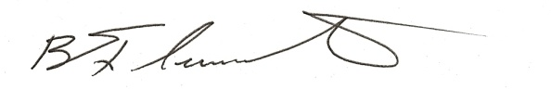
Mr. Brian Fleischman, Principal
308-987-2424 x206
brian.fleischman@overtoneagles.org

